AI Consulting Copilot
An Intelligent Multi-Agent Platform for AI Strategy Discovery

1. The Problem Being Solved
Most organisations want to adopt AI but do not know where to start. Traditional AI strategy consulting is slow and expensive: it requires multiple consultants, several rounds of interviews, and weeks of analysis before any output is delivered.
The core problems this platform addresses are:
- Discovery takes too long — weeks of interviews and workshops before any output
- Insights stay with the consultant — internal teams cannot reproduce the thinking
- Outputs are generic — strategy decks rarely reflect the specific operational reality of the client
- Smaller organisations cannot afford traditional consulting engagements

2. The Solution
AI Consulting Copilot compresses the entire discovery and strategy process into one collaborative session. The platform does this by:
- Pre-loading industry knowledge before the session starts, so the system arrives informed
- Guiding participants through structured phases and exercises in real time
- Clustering, scoring, and prioritising inputs automatically as they are submitted
- Adapting its language and coaching based on the team's actual AI confidence level
- Generating a complete strategy deck, roadmap, and readiness report at the end

The platform's authority comes entirely from reflecting the participants' own intelligence back at them in a form they could not have produced alone. Nothing is invented — everything is surfaced, structured, and returned as strategy.

3. How the Platform Understands Context
The platform operates on a three-tier data model that allows it to synthesise multiple layers of context simultaneously during a session.

Tier | Layer | What it contains
Tier 1 | Industry | Sector benchmarks, common AI use cases, peer adoption data. Pre-loaded before the session begins via industry R&D, live data scraping, and competitor AI audits. Global adoption statistics — e.g. lead generation AI adopted by ~30% of companies, DevOps AI by under 5% — feed Phase 6.
Tier 2 | Company | Organisation-specific context — size, departments present, strategic priorities, and operational challenges surfaced by participants. Built live as the workshop progresses.
Tier 3 | Individual | Each participant's role, department, daily pain points, AI confidence level, and prompt engineering output. Shapes how the system interprets every input for the rest of the session.

When two or more companies in the same industry independently surface the same problem, that problem receives a sector-validated signal.

4. Workshop Flow
A session runs through eleven phases and three interleaved activities. Each phase builds on the previous one. The goal is to move from "We want AI" to "Here is a clear, data-grounded AI implementation roadmap."

Stage | Name | What happens
Phase 0 | Workshop setup | Host configures industry, participant count, and duration. System pre-loads industry AI benchmarks, common use cases, adoption patterns, and competitor initiatives via R&D and live scraping. Benchmarks load before anyone joins.
Phase 1 | Onboarding | Participants join via link or QR code. Declare name, role, department, main responsibility, and top challenge. Stakeholder map builds live. Company is identified at this point to personalise the context layer.
Phase 2 | Business context | AI facilitator collects strategic objectives and operational challenges via live polls and short text inputs. Insight Mining Agent clusters responses in real time. Output: business objective map.
Phase 3 | Problem discovery | Participants submit specific operational pain points. System clusters them by department and theme, detects cross-department patterns, and flags industry overlap signals as suggestion cards.
Act. A | Data audit | Each participant scores their key datasets on location, cleanliness, history, and ownership. Produces a data readiness map — e.g. Lead generation → high readiness, Support automation → medium, Predictive maintenance → low.
Act. B | AI confidence | Participants self-rate on a five-level spectrum (Skeptical to Expert) and flag concerns such as job replacement, security, or cost. System generates a team confidence profile and adapts its language for the rest of the session.
Act. C | Prompt engineering | Participants write a plain-English instruction for an AI assistant using their own real problems. System scores it, rewrites it for precision, and runs a live AI simulation on the participant's actual problem. The abstract becomes concrete.
Phase 4 | Opportunity generation | System synthesises all inputs — problem clusters, prompt insights, data readiness, and industry benchmarks — and generates ranked AI use case cards tagged as org-generated or sector-validated. Each card includes impact estimate, complexity rating, and data readiness score.
Phase 5 | Initial poll | Participants vote on which AI opportunities interest them most. This first vote captures raw preference before any external data is introduced. Serves as a baseline for measuring how education changes thinking.
Phase 6 | Global adoption insight | System surfaces external intelligence: which use cases are widely adopted globally, which have demonstrated high ROI, and what AI looks like in this industry. This is an education window — participants learn the current state of AI, its scope, and adoption trends. Powered by R&D on other companies' AI audits and competitor data.
Phase 7 | Second poll | Participants vote again after seeing global benchmarks and success patterns. Results are ranked. System detects true consensus by comparing shift between Poll 1 and Poll 2. A use case that gains votes after education carries more weight.
Phase 8 | Prioritisation | Top-voted use cases placed in an Impact vs Effort matrix. High Impact + Low Effort → Quick Wins. High Impact + High Effort → Strategic Projects. Low Impact → deprioritised. Most-voted use case triggers the Agent Builder to scaffold a live demo.
Phase 9 | Readiness assessment | Four-dimension score across data maturity, AI expertise, automation infrastructure, and system integration capability. Data maturity and AI expertise are pre-filled from the activities. Final score benchmarked against industry.
Phase 10 | Roadmap generation | Three-phase implementation roadmap. Phase 1 — Quick Wins: start now. Phase 2 — Operational Transformation: medium-effort use cases requiring data work first. Phase 3 — Advanced Intelligence: predictive analytics and complex AI systems.
Phase 11 | Deliverables | Strategy deck, use case list, readiness report, roadmap, data gap plan, data audit report, agent build report, and full session transcript. All available through a read-only client portal link.

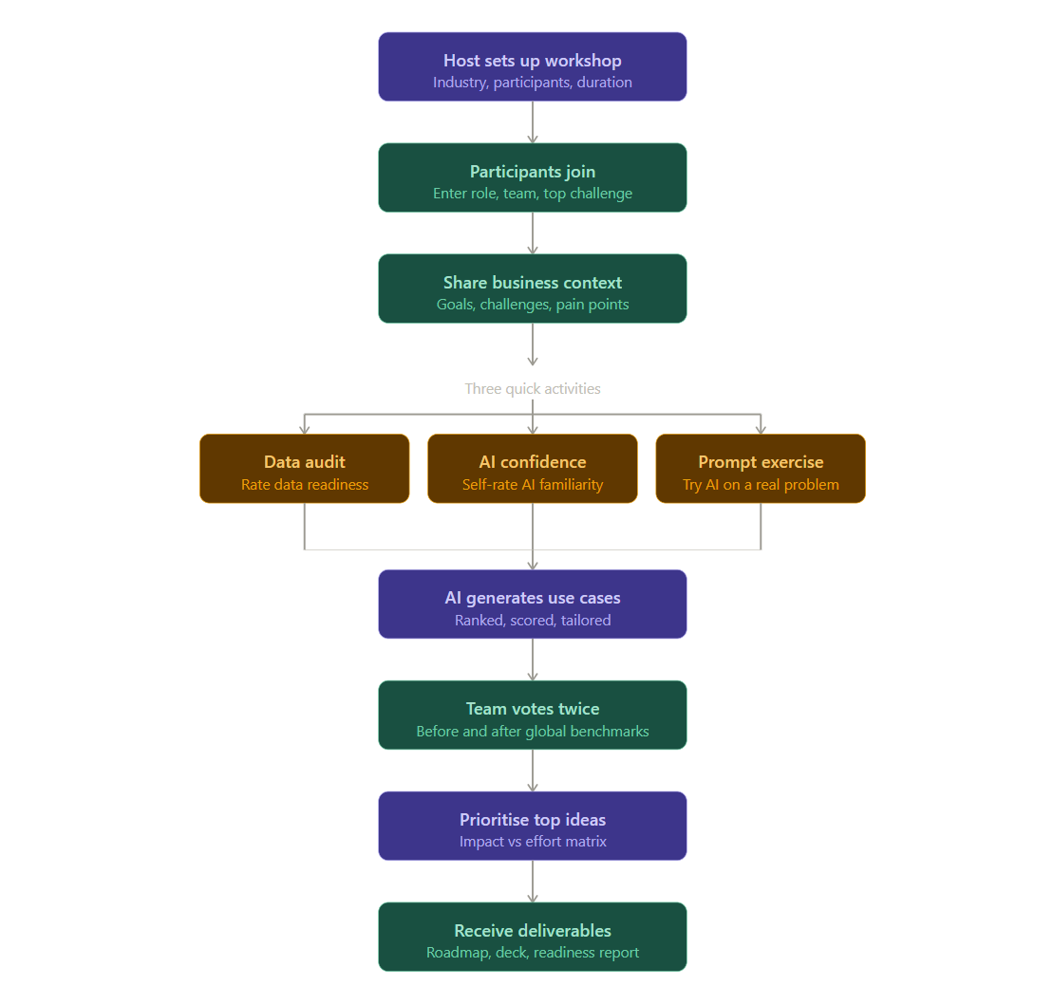
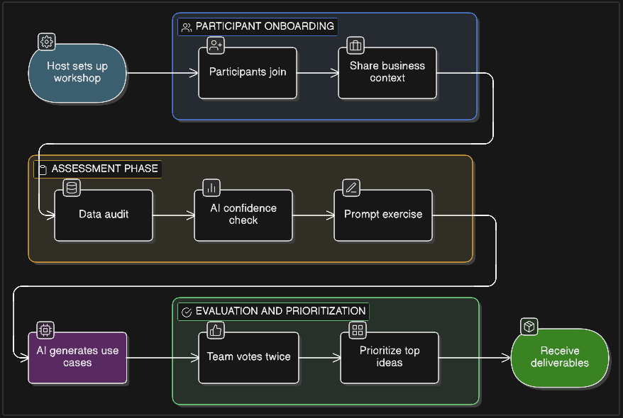

5. Why the Activity Sequence Matters
The three activities are not simply data collection exercises. They are designed in a specific sequence for both practical and emotional reasons.

- Activity A (Data Audit) runs first because it grounds participants in reality. Before speculating about AI solutions, participants discover whether their data could actually support those solutions. This prevents the session from generating a wishlist that collapses the moment someone asks where the training data would come from.
- Activity B (Confidence Spectrum) runs second because the data audit often surfaces anxiety. Participants who discover their data is in poor shape may feel discouraged. The confidence activity gives that feeling somewhere to go — and the system immediately adapts its tone for the rest of the session based on the team's collective profile.
- Activity C (Prompt Engineering) runs third because it builds on both. The system knows which problems are data-ready from the audit, and knows how technical to make its feedback from the confidence spectrum. Participants interact with a live AI simulation of their own problem. This is the moment the abstract becomes concrete.

6. Core Workshop Agent Architecture
The platform runs seven coordinated AI agents built into the workshop engine. Each has a distinct responsibility and operates at a specific point in the session flow.

Agent | Responsibility
Facilitator Agent | Guides the session, asks questions, and transitions between phases. Active throughout all phases.
Poll and Consensus Agent | Manages live voting in Phase 5 (initial poll) and Phase 7 (second poll). Aggregates input, ranks results, and detects alignment across stakeholders.
Prompt Coaching Agent | Activates exclusively during Activity C. Evaluates participant prompts, rewrites them for precision, and runs live AI simulations on the participant's own real problem.
Insight Mining Agent | Runs continuously from Phase 2 through Phase 3. Clusters responses, detects cross-department patterns, and surfaces strategic observations in real time. Builds the business objective map and problem cluster map.
Industry Benchmark Agent | Activates in Phase 6. Provides contextual recommendations based on sector trends and peer company data sourced from R&D on other companies' AI audits and competitor use analysis.
Prioritisation and ROI Agent | Activates in Phase 8. Evaluates use cases on impact, feasibility, data readiness, and estimated value. Places them in the Impact vs Effort matrix.
Deck Builder Agent | Activates in Phase 11. Transforms all workshop outputs into the strategy presentation, roadmap, and deliverables package available through the client portal.

7. Platform Agents — Already Built, Integration Required
The following four agents are fully built as standalone platforms. They are not part of the core workshop engine. They require integration at specific points in the session to increase interactivity and deliver the consult + learning experience. Each agent is described below with its integration point and the reason it belongs there.

AI Meeting Agent | Integrates from Phase 0 through end of session
What it is | AI-powered meeting assistant that automatically records, transcribes, summarises, and organises calls. Extracts action items, highlights key moments, and stores meetings in organised folders. Compatible with Zoom and other video platforms.
Integration point | Joins the session at Phase 0 startup — before participants arrive. Runs as a companion window visible on screen throughout the entire workshop. Records all audio, identifies and names each speaker, and transcribes in real time. During Phase 1 onboarding it begins assigning speaker identities to participants.
Why here | Provides a live transcript layer that the facilitator and participants can reference throughout the session. Captures everything that is said — including informal remarks that reveal important context — without requiring manual note-taking from the host.
Post-session role | After the workshop, the Meeting Agent's transcript, AI summary, and extracted action items feed directly into the final deliverables package. The session recording is stored in a client folder accessible through the portal.
Output | Full session transcript, AI-generated summary, extracted action items, speaker-identified recording, session folder in client portal

AI Smart Coach | Integrates at Phase 3 → Activity B → Phase 6
What it is | AI-powered coaching agent that provides real-time conversation analysis, role-playing scenarios, and personalised coaching feedback. Features include voice avatars, conversation transcripts, real-time scoring, and performance reports.
Integration point 1 — Phase 3 | Begins reading emerging problem clusters and adjusts its communication posture for the group. Identifies whether the team is technically literate or needs simpler framing.
Integration point 2 — Activity B | Primary calibration moment. Reads the team's collective AI confidence profile and permanently sets its tone, vocabulary depth, and coaching style for the remainder of the session. A skeptical team gets education-first framing. A practitioner team gets technical depth and implementation focus.
Integration point 3 — Phase 6 | Delivers the Global Adoption Insight as a structured education window. Teaches participants the current state of AI, what fields of AI apply to their industry, the scope of AI training, and where adoption is heading. This is the consult + learning moment — participants leave understanding AI, not just holding a document.
Output | Calibrated facilitation tone throughout session, education content in Phase 6, coaching transcript, role-play scenarios for confidence-building if needed

Training Agent | Integrates at Phase 6 education window
What it is | Interactive training platform that drives intelligent workflow learning through live Q&A, real-time scoring, and dynamic mind map generation. Adapts learning paths based on participant performance and confidence level.
Integration point | Phase 6 education window. Delivers structured AI micro-learning to participants — what machine learning is, how LLMs work, what automation can and cannot do — calibrated to the confidence level established in Activity B. Makes the education window interactive rather than a passive presentation.
Why here | The mentor notes explicitly call for: educate them in fields of AI, draw current state of AI, scope of AI learning in field of AI. The Training Agent is built precisely for this — live Q&A, scoring, and mind maps for visual learners. It transforms Phase 6 from a slideshow into a learning session.
Output | Live Q&A on AI topics, personalised learning path per confidence level, mind map of AI landscape relevant to the industry, scoring and progress summary per participant

Agent Builder | Integrates after Phase 8 — post prioritisation
What it is | Interactive platform for building AI agents live in a session. Supports agent scaffolding, demo generation, and report creation. The most-voted use case from Phase 8 becomes the subject of a live agent build.
Integration point | Activates immediately after Phase 8 prioritisation is complete. The most-voted use case is passed to the Agent Builder, which scaffolds a working demonstration agent in real time — visible to all participants through the companion window.
What it does in session | Participants see a real agent built from their own most-voted problem. The Agent Builder generates an agent build report documenting what was built, how it works, and what would be required to deploy it. This report feeds into the final deliverables package.
Product Demo Assistant — showcase layer | After the Agent Builder produces the demo agent, the Product Demo Assistant presents it interactively via an AI avatar. Participants can ask questions about the agent in real time. The demo is recorded and stored in the client portal. Participants leave with a working demo, not just a strategy deck.
Output | Live demo agent for most-voted use case, agent build report, interactive avatar-based demo via Product Demo Assistant, demo recording in client portal

8. What the Client Receives
At the end of every session, the platform automatically generates the following outputs and makes them available through a read-only client portal link.
- Strategy presentation deck — ready to present to leadership
- Prioritised AI use case list with impact and complexity scores
- AI readiness report with industry benchmark comparison
- Three-phase implementation roadmap
- Data gap action plan — what to fix before tackling each use case
- Data audit report — full dataset readiness breakdown
- Agent build report — documentation of the demo agent built in session
- Full session transcript and AI summary from the Meeting Agent

9. Who This Is Built For
The platform serves organisations that need AI strategy quickly and without the overhead of a traditional consulting engagement.

User | How they use it
Consulting firms | Run scalable AI discovery workshops for multiple clients without needing a large analyst team.
Enterprise innovation teams | Run internal workshops to identify automation opportunities across departments.
Strategy and transformation leaders | Align cross-functional teams around a shared AI roadmap in a single session.
Technology leaders | Translate business challenges into a structured, prioritised AI implementation plan.

